Final Exam Project

Alpha Strength Supplements



Table of Contents

Mission Statement ………………………………………………………………………………..2

Business Organization ……………………………………………………………………………3

Business Structure ………………………………………………………………………………..4

Manufacturer ……………………………………………………………………………………..5

Name of Product & Product Line ………………………………………………………………...6

Alpha Strength Smooth Energy Capsules ………………………………………………..7

Alpha Strength CLA 1,000 mg Capsules ………………………………………………...8

Alpha Strength Protein Powder (Chocolate) ……………………………………………..9

Alpha Strength Protein Powder (Vanilla) ……………………………………………….10

Alpha Strength Fat Burner……………………………………………………………….11

Pricing & Minimum Order Quantity (MOQ) ……………………………………………………..6

Pricing Strategy………………………………………………………………………………..…12

Location of Product Marketing ………………………………………………………………….13

Business Model ………………………………………………………………………………….13

Budget …………………………………………………………………………………………...14

Mission Statement
To create effective and natural supplements at affordable prices for dedicated athletes.

Type of Business Organization: Corporation
The reason for selecting a corporation as the type of business organization for my company is primarily because of the ability to separate the entity apart from myself, the owner. I believe the life of the corporation should be independent of its owners and allow for potential shareholders to come into the company and take on ownership. Incorporating Alpha Strength Supplements also gives potential power to raise large amounts of capital by selling shares of ownership to outside investors if need be. There are abundant advantages to incorporating my company. One of the primary ones being limited liability of investors, making it possible to limit their liability to their total investment amount and not a penny more. Another advantage of incorporating Alpha Strength Supplements would be ease of transferring ownership years ahead along with the ability to continue indefinitely.

Organizational Structure: Simple Structure
The reason for selecting a simple organizational structure for Alpha Strength Supplements is because it is a small organization being that it is a start-up and has a narrow product line. Another reason for being a small organization is that as the owner-manager, I would be making most, if not all of the decisions. The advantages of a simple structure includes being informal and having employees under direct supervision. This type organizational structure would provide my future employee(s) with ease since it would not be a formal environment and she or he would not be dealing with multiple levels of management as one would at a larger company. Other advantages that are related to the informality of the simple organizational structure would be fewer rules and regulations to abide by along with more direct reward systems. Although I am aware that employees are prone to take advantage when strict rules and regulations do not exist, I do not see this aspect affecting productivity in my company. This is because I will maintain a close relationship with my employee(s), thus discouraging negative behavior.

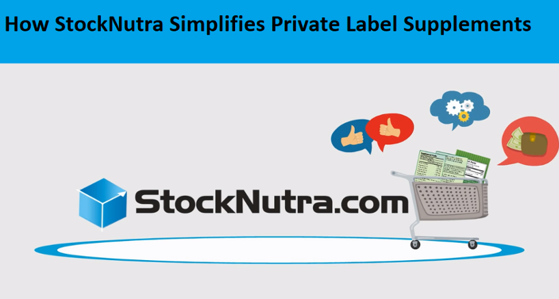
Manufacturer:



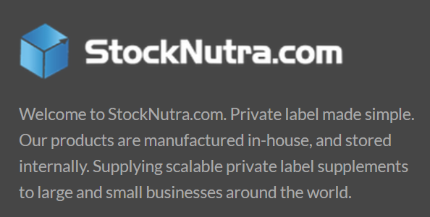


ABH Pharma Inc. - StockNutra
131 Heartland Blvd.
Brentwood, NY 11717
United States
(844) 606-8872
www.StockNutra.com

Name of Product: Alpha Strength Supplements

Product Line:
- Alpha Strength Smooth Energy Capsules
- Alpha Strength CLA 1,000 mg Capsules
- Alpha Strength Protein Powder
  - Chocolate
  - Vanilla
- Alpha Strength Fat Burner

Pricing: See pages 6-10 for pricing of individual items

Minimum Order Quantity (MOQ): 500 units
The minimum order quantity for all the products to be manufactured by StockNutra is 500 units.

Alpha Strength Smooth Energy Capsules:

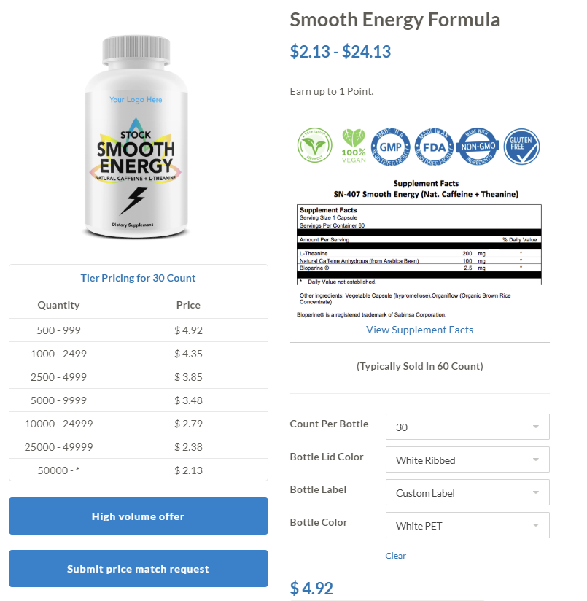

Alpha Strength CLA 1,000mg Capsules:
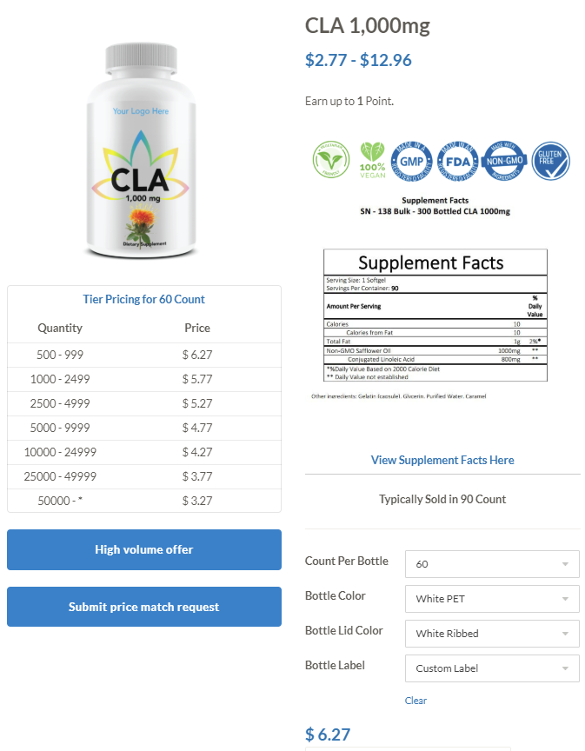

Alpha Strength Protein Powder (Chocolate):

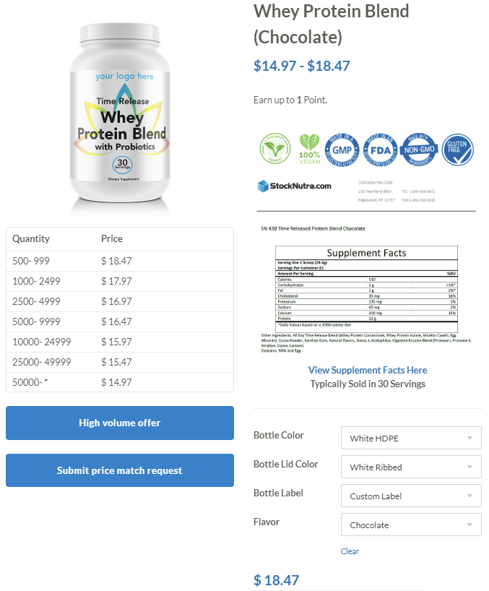

Alpha Strength Protein Powder (Vanilla):

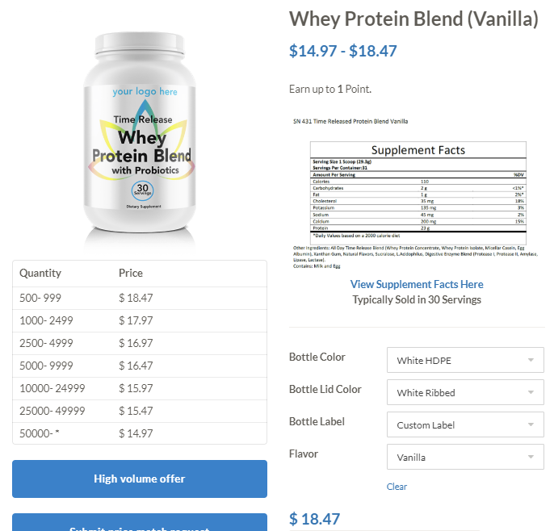

Alpha Strength Fat Burner:
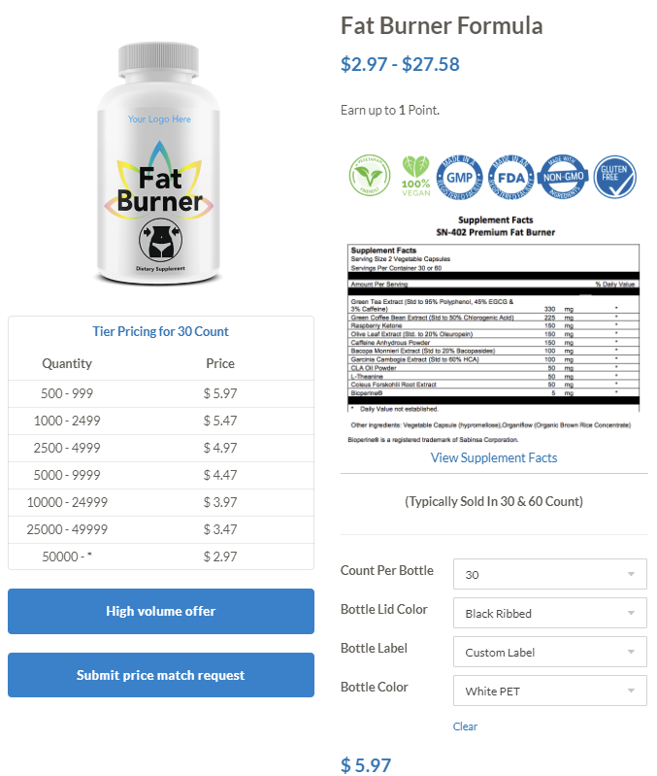

Pricing Strategy:

Cost to Alpha Strength Supplements:
Product | Cost | Quantity
Alpha Strength Smooth Energy Capsules | $4.35 | 1,000 | $4,350.00
Alpha Strength CLA 1,000mg Capsules | $5.77 | 1,000 | $5,770.00
Alpha Strength Protein Powder (Chocolate) | $17.97 | 1,000 | $17,970.00
Alpha Strength Protein Powder (Vanilla) | $17.97 | 1,000 | $17,970.00
Alpha Strength Fat Burner | $5.47 | 1,000 | $5,470.00
TOTAL COST |  |  | $51,530.00*
*Product packaging and label costs not included in this figure
Pricing Strategy:
Product | Price | Quantity
Alpha Strength Smooth Energy Capsules | $14.50 | 1,000 | $14,500.00
Alpha Strength CLA 1,000mg Capsules | $19.23 | 1,000 | $19,233.33
Alpha Strength Protein Powder (Chocolate) | $59.90 | 1,000 | $59,900.00
Alpha Strength Protein Powder (Vanilla) | $59.90 | 1,000 | $59,900.00
Alpha Strength Fat Burner | $18.23 | 1,000 | $18,233.33
TOTAL REVENUE |  |  | $171,766.67

Net Profit | $120,236.67
Profit Margin | 70.00%

To further elaborate on Alpha Strength Supplements’ pricing strategy, every product will be marked up 70% from the unit cost to us, thus allowing roughly 70% profit margins. The reason for this is because StockNutra does not include the costs of shipping and custom labels in their pricing. If these costs were accounted for as well, the profitability would decrease slightly.

Location of Product Marketing: United States
Alpha Strength Supplements will market their products in the United States of America. This is because I am more familiar with the American market compared to the international market and want to do business on a national level first. As a start-up company, it would not be wise to launch globally, due to all the costs that would be factored in along with this. Some of these expenses are related to additional advertising costs, shipping costs, and taxes. Doing business on a national level is far more simpler when the company is a start-up. Furthermore, growth becomes possible and then later enhanced when there is a narrow focus on product marketing.

Business Model: Retail
Alpha Strength Supplements will follow a retail business model because of the opportunity for greater profit margins. The target group for the beginning will be anyone who has interest in weight training. The method of advertising to this target group would primarily be through social media and sponsorship of particular models and athletes who have websites or social media pages dedicated to weight training. For the first few years of doing business, Alpha Strength Supplements will operate and sell their products in the retail market. Depending on how successful Alpha Strength Supplements is within the first few years will determine whether we have captured enough market share to distribute through the wholesale market such as grocery stores, gymnasiums, vitamin shops, and online.

Budget:

Item: | Amount ($):
Advertising (Website/Social Media) | $10,000.00
Employee Salary | $40,000.00
Supplements from StockNutra | $51,530.00
Shipping | $6,000.00
Custom Labels | $8,000.00
Rent | $0.00
Utilities | $0.00
Tools and Supplies | $2,000.00
TOTAL | $117,530.00

The table above conveys the amount of capital necessary for to begin doing business for Alpha Strength Supplements. The costs are annualized and estimated as close as possible to the exact amount necessary. As far as rent and utilities are concerned, those are expected to be $0 because for the first couple years I will be operating from home.

